Human Interdependence

Notes for Adults:
Our presentations are going to be almost like a fairy tale, because the concepts are extremely simple, while our societies function in a complex way. Nonetheless, they convey the basic ideas extremely well. Simplicity gives the stories a fairy tale quality, and we are also going back to Medieval times. The work is so simple that it can come quite early for the children. It totally connects with Fundamental Human Needs, which can also be introduced early in the Elementary.

Pre-requisite: Fundamental Human Needs intro (lesson here)

Children become aware of how much we use all three kingdoms of nature in order to satisfy our needs. The chart shows how truly dependent on nature we are. Looking at the chart we see nature everywhere. We want the children to feel gratitude for nature spontaneously; we don't want to manipulate the children in any way (lectures, adult-driven charity projects) in order to purposely provoke gratitude. Remember that they are in a sensitive period for morality, so they will develop their own views on gratitude and interconnectedness on their own.

We want to focus on the human element (the work of human beings), which permits us to satisfy our needs.

IMPORTANT: These conversations can take place over several weeks. While it’s important to work linearly (first group, second group, third group), it’s ok to leave gaps of time between activities and to encourage the children to take the cards out on their own (after the initial activity lesson from each group), make their own cards, drawings, stories, and connections.

Notes on Materials:

6 folders, coded into three groups: A, B, C
A1, A2, A3; B1, B2; C1
*These folders are examples; if the children want more, they have to make it on their own.*

GROUP A:
A1: From whom do we get our food? (bread)
A2: From whom do we get our food? (meat)
A3: From whom do we get our clothes?

GROUP B:
B1: Whom does the farmer need?
B2: Whom does the toolmaker need?

GROUP C:
C1: What does the farmer produce?

Character cards: (print all the characters that you need for each set you’re making, referring to the activities below to determine which characters you need for each activity)

Cards available on TpT: click here

Notes on these cards:
- These cards can be easily hand-drawn if you have time. The images of the workers are by nature simple and faceless, because we want to inspire the children to make their own. Basic outline drawings are fine!
- The “transporter” cards are optional if you want to talk about how goods get from one place to another. With younger children (6-year-olds), skip the transporter cards and focus on the fundamental occupations.

IMPORTANT: Our focus is on the people, not the things they make. This makes the work human. The farmer and the toolmaker are fundamental occupations, which changed human lifestyles and allowed humans to settle.

The difference between 2nd and 1st plane children is that we want the 2nd plane children to think about work as a foundation of human society.

BOOKS:
Prior to the lessons, make sure you have a few books about where food comes from. Here are two suggestions we have at home:
How Did That Get In My Lunchbox? The Story of Food
Right This Very Minute: A table to farm book about food and farming

Your library can be a good source for these books if you do a search on “farm to table books”

PRESENTATION:

Start with a recall: Review the FHN chart with the children if you already presented it (see lesson in History section, here). Otherwise, first give that lesson, and then move into this one.

ACTIVITY 1: Folders A1, A2, and A3 / From whom do we get our food?

Folder A1: (Given as a conversation with cards)
- Today we want to think about food. It is a need we have to satisfy rather often. What we most often shop for is food.
- Take out folder A1 with these images: the baker, the miller, the farmer
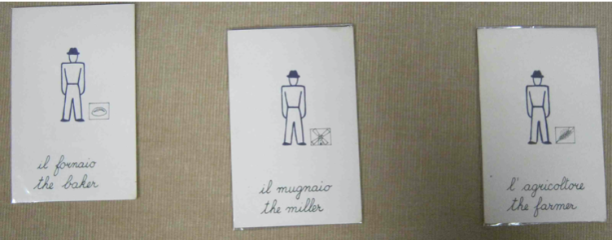
- Discuss what the children had for breakfast or lunch (depending on the time of year). (You hope that bread or other grain products come up quite often in the conversation).
- Ask: From whom do we get our bread? Let the children answer - "The baker".
- Lay out a card that shows a picture of the human being with a little loaf of bread within the rectangle next to him.
- The loaf of bread is telling us what his activity is; it's as though he has an ID card.
- Ask: What does the baker do to make the bread? He uses water, yeast, flour, and salt. He mixes it together to make a dough. He kneads the dough and leaves it in a warm place to rise. Then he shapes the dough into loaves and bakes the bread.
- When the bread is fresh it is so marvelous and tastes delicious! (Invite the children to think of adjectives to describe the bread).
- The baker works quite hard! The baker wakes up long before any of us so that he can make the bread that we're going to eat during the day.
- We don't know most of the bakers, we don't know how they look or what their names are, but we certainly need their work - we need the bread. There is no face to tell us who he is, but the loaf of bread tells us he's the baker.
- What did you say the baker uses to make bread? Flour!
- From whom does the baker get flour? From the miller!
- Take out the card that represents the miller. We have the same figure of the human being - the worker - but this time in the little rectangular box we see a windmill. We probably say miller because once upon a time people did use windmills (and sometimes water mills) to help them obtain the flour.
- What did the miller do to make the flour? He took grains of wheat and ground or milled those grains in order to obtain the flour. This is a job that requires a lot of energy. Long ago, people used to grind wheat by hand. Then they wanted to have help, so for a long time they used windmills to help turn one stone against another to grind the grain. Then the miller sifted the milled grain in order to separate the flour from the husks.
- You can imagine that the miller has to work hard as well so that the baker can have his flour so that we can have our bread.
- We don't know who the miller is, what he looks like, or what his name is. We know nothing about him and yet he's the one who provided the flour so that the baker can make the bread that we eat.
- From whom does the miller get the grains of wheat? From the farmer!
- Here is the card for the farmer, which is the same human figure with an ear of wheat in the rectangular box.
- What does the farmer do so that the miller can have the grain?
- The farmer chose the best grain. There's a certain time of the year when the harvesting is done, where the farmer chooses the best grain and saves it. He stores it because the grains are actually seeds. Then, when the time is right the farmer prepares the ground, plows the land, fertilizes the soil, sows the seeds, waters the field, weeds the field and looks after the growing wheat. When the wheat is ripe, the farmer cuts the wheat (reaped the wheat), ties the wheat into sheaves and leaves these to dry in the sun. Then the farmer carries the wheat from the field and threshes it (beats it) to separate the grains from the stalk. Then, the actual grain has to be separated from the rest - the chaff – and this is called winnowing. Finally, he can store the grain in his barn. After all that work, the grain is ready for the miller. But the farmer had to work really hard so the miller could have his grain, so the baker could have his flour, so we could have our bread.
- Do we know the farmer from whom we got the grain? No, we don't know his name or what he looks like or his history. That farmer is nameless and faceless, and yet he did all that work that permitted us to have that bread.
- Now we know where we get our bread from (you can go through the whole sequence and then in reverse orally to re-enforce)
- Invite the children to read the relevant book(s) that are provided for them.
Folders A2 and A3:
*After you present folder 1 (above) invite the children to explore the other two on their own (below) and ask them to share with you what they’ve discovered. From there they can engage in many follow-up activities based on their curiosity. They can also make their own cards based on their research.

A2 (cards not available, you’ll need to make your own or skip this one): butcher (knife) <-- slaughterer (live animal and knife) <-- stock farmer (live animal)

A3 (see printable): tailor (needle and thread) <-- shopkeeper (shop) <-- textile maker (toothed wheel/gear) <-- the farmer (cotton boll)

ACTIVITY 2: Series B

Folder B1: Whom does the farmer need?

Note: Use the cards from the printable A and C folders. The cards will be set out in a circle, with the one who depends on the others being in the CENTER (so for the lesson with folder B1, the farmer will be in the center).
- Whom do we need for our bread ultimately? Who did it go back to? The farmer. The same happened for our meat and our clothes.
- For our bread, meat, and clothes we needed the farmer in one way or another.
- We can also think of other things we need the farm for. It looks as though everyone needs the farmer.
- Whom does the farmer need? Everyone has basic/fundamental needs, and so does the farmer.
- Take out the card showing the farmer with the ear of wheat.
- Does the farmer need bread? Yes. He can provide many things for himself and he certainly grows the wheat, but he probably needs the baker because he might not always want to make bread. Place the baker card under the farmer card
- Does he need meat? Yes, so perhaps he needs the butcher. Place the butcher card to one side of the farmer card. (The cards start forming a circle around the farmer.)
- Does he need clothes? Yes, so he will need the tailor. Place the card in a growing circle around the farmer.
- Does he need shoes? Yes, so he will need a shoemaker. (circle continues to grow)
- Does he need repairs on his farm? Yes, so he will need to have a mason to keep his buildings in good repair.
- For his home, he will need pots & pans as well as cutlery. He'll also need hammers, shovels, spades, hoes and plows for his tools. He'll therefore need the toolmaker.
- The farmer must be very happy that he can receive all these things from others rather than having to make them all himself.
- Even the farmer who produces so much depends on other people to satisfy his needs. Maybe he feels a sense of unity with all these other workers because surely as he produces things that he provides to others, so he provides goods and services from others. The farmer provides but the farmer also receives.
- Each of us can occupy that center position, which indicates needs and interdependency with others. We use the services of others, depend on services of others and provide services for others. This too is a circle of solidarity.
Note: Use the same set of cards to illustrate the inter-dependency of the toolmaker to the other product/service providers. The toolmaker's "object" in the rectangle is a pair of pliers. Go through the fundamental human needs to see which needs are satisfied and by whom:
  - food: baker, butcher, greengrocer (pic of fruits/veg)
  - clothing: tailor, shoemaker (shoe or boot)
  - shelter: mason (trowel)
  - raw material: smelter (pouring melted metal)
  - coal: miner (safety helmet)
Note: We again see the circle of solidarity. The workers work for us but we do not know them in any personal way. Montessori wants us to be aware that there are people who work for us. Since they are faceless and nameless, she calls them "uomini senza volto". (men without a face).

ACTIVITY 3: Series C

C1: What does the farmer produce?

Additional material: Food groups cards (purchase here)
Note: We have one example but the children can investigate the goods made by each of the professions.
- The folder says: "What does the farmer produce?
- Place the picture of the farmer in the center of the workspace.
- We've seen that everyone needs the farmer, at least indirectly.
- We've also seen whom the farmer needs: we've seen how each worker and producer, through his work, produces goods and services for other people because no one worker uses everything he produces. Each kind of worker produces some products but not others. This means the work is specialized.
- Today we want to look at what the farmer produces. It might be many things but it's not everything.
- Shuffle the picture cards with different food groups, put them out one at a time around the farmer and talk about them. (Your cards might be slightly different than these, so adapt your conversation to your material)
  - Grain (wheat): The farmer produces wheat. It gives us bread.
  - Sugar beet: Invite the children to participate and share their thoughts.
  - Grapes (wine, juice): Children can discuss
  - Fruits (cherry, pear, apple, orange): continue discussing with all the rest
  - Vegetables (cabbage, artichoke, tomato)
  - Livestock (meat - cow)
  - Dairy products (cheese and milk)
  - Poultry (chicken and egg)
  - Cotton (cotton bolls)
  - Wool (sheep)
  - Silk (cocoon on mulberry leaves)
Note: When the cards are in a pile, it gives us the impression of a cornucopia of goods that are produced by the farmer. We can think that each producer has his own basket of goods to offer the community.

Follow-up: Classify the cards by kingdom (plant, animal, mineral) and then by need (shelter, food, clothing, etc. ).

Conclusion for adults:

Looking back, we think of the layout of the cards, which helps the children to visualize:

Series A: we worked in a line with the cards
Series B: circle around one card (a community that provides for and supports each one of us, because any one of us can be at the center of the circle)
Series C: the idea of the cornucopia, an impression of abundance and plenty

All the activities are helping the children to understand how we are dependent on the work of others and therefore how much other human beings contribute to our lives.

ACTIVITY 4: Building Interdependence
- Take the series B cards showing the interrelationship of the toolmaker with other goods/service providers. Lay the cards out around the toolmaker card.
- Take a piece of paper. Put the toolmaker card at the top of the paper. Put the baker card at the bottom of the paper.
- Invite the children to choose a color to highlight interdependence.
- Draw a colored line (e.g. red) from the toolmaker to the baker.
- Ask: Does the baker need the toolmaker? Yes (discuss with the children why this is so).
- Invite them to choose a different color and draw a parallel line.
- Turn the paper over because we are now bringing in the butcher.
- Move the baker card to one side of the paper and put the butcher on the other side of the paper.
- Draw a line from the toolmaker to the baker and the toolmaker to the butcher. Draw lines from the baker and butcher to the toolmaker.
- Discuss the dependency of the baker to the butcher and the butcher to the baker, drawing lines from each in different colors and making a triangle.
- On a fresh sheet of paper, lay out the toolmaker (top), butcher and baker (sides), and tailor (bottom).
- Draw the lines we already know from the toolmaker to the butcher and baker, and then also to the tailor.
- Then draw the lines from the baker to the butcher and the tailor, and from the butcher to the baker and tailor.
- Choose a color for the tailor and discuss the interdependences.
- Go back to the line: it's one two-way relationship.
- The triangle illustrates a three-way relationship.
- The rhombus with diagonals shows SIX RELATIONSHIPS even though there are only four workers.
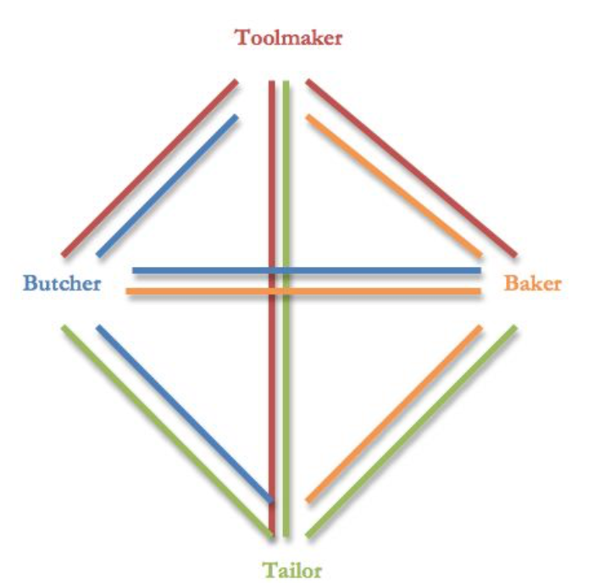
Note: Every profession should have its own color!!

Reaching a network of interdependence (this is an activity for a large group of people):
- Invite the children to find all the different workers that we have. We don't want to duplicate them, but we can maintain the farmer in his three different roles: cotton farmer, wheat farmer, and stock farmer.
- The children will find 16 workers. We therefore need to make a hexadecagon (see instructions below) and place one worker on each of the vertices of the hexadecagon.
- The children can lay out the cards in order by how they relate to each other to satisfy one need, or in any way they want.
- Each child should choose one color and one worker, and they can discuss the interrelationships. Some of the workers will not have relationships with others (i.e. the cotton farmer does not need the textile salesman)
- There are 116 relationships in this "who needs whom" game.
- (see picture on next page)
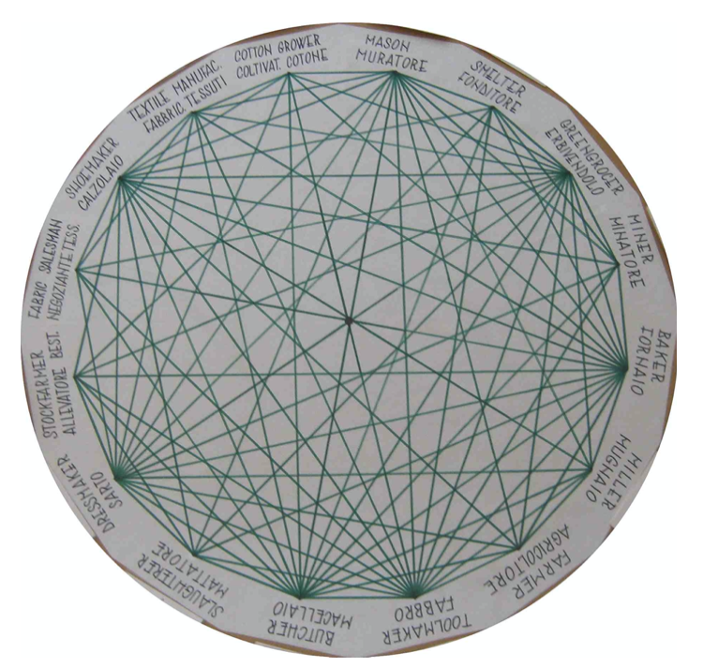
Practical point: Once the children have decided where the workers are going to go, they can write the names of the workers at the vertices and put the cards away.

Reflect with the children: The rule was that each worker is more or less dedicated to his own work. Therefore, he cannot supply himself with his other needs completely (i.e. we occasionally make our own bread but we don't make it all the time). This is an example of specialization. In real life, we're not limited to just 16 workers in a community. The 116 relationships we find here are in reality so many more. The design reminds us of a web of relationships, which we can think of as a network of interdependencies.

This gives us an impression of how our society functions when there is specialization. This is a network of solidarity. We've seen a line of solidarity working with the A series, the circle of solidarity working with the B series, and we've seen what an abundance of products can be produced by a particular worker with the C series. Each product has a line or chain of interdependence and solidarity. We've seen how we depend on others and how others depend on us.

This work can start by the age of 7. At every stage of the work, the children can fill in gaps for themselves, thinking of all the other workers/producers that are involved in their own lives.

MAKING A REGULAR HEXADECAGON:
- Start with a square paper that measures 50 cm. along its side.
- Fold it in half, vertex to vertex, to get an isosceles triangle.
- Fold again to get a smaller isosceles triangle.
- Fold it a third time to get a smaller isosceles triangle.
- The fourth fold is from an isosceles to an obtuse-angle scalene.
- Then, you want to get the long side equal to the medium side, so you fold the medium side over to the long side and mark the long side.
- Draw a line from the vertex of the medium side to the mark on the long side.
- Cut along the line.
- Open it out and you will have a hexadecagon.

Note: You should make the hexadecagon for them and let them do the interrelationship activity. They can learn to make the hexadecagon as a follow-up activity.

